ASSIGNMENT – 3

Artificial Intelligence & Machine Learning in

collaboration with Google (Applied Data Science)

Submitted by:

Sandeep K.S.

21BME0158

B.tech at VIT,Vellore

Answers

1. Download the dataset: Dataset
2. Load the dataset into the tool.

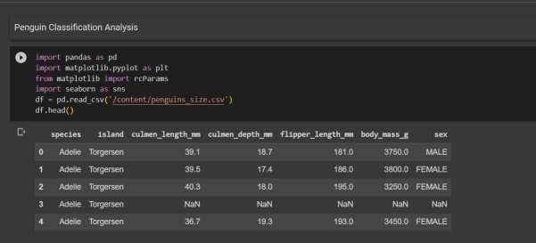

1. Perform Below Visualizations.
   * Univariate Analysis

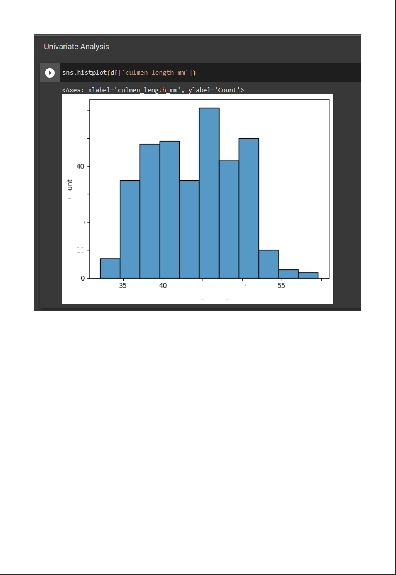

60

50

lO

45 50 60

cuImen_Iength_mm

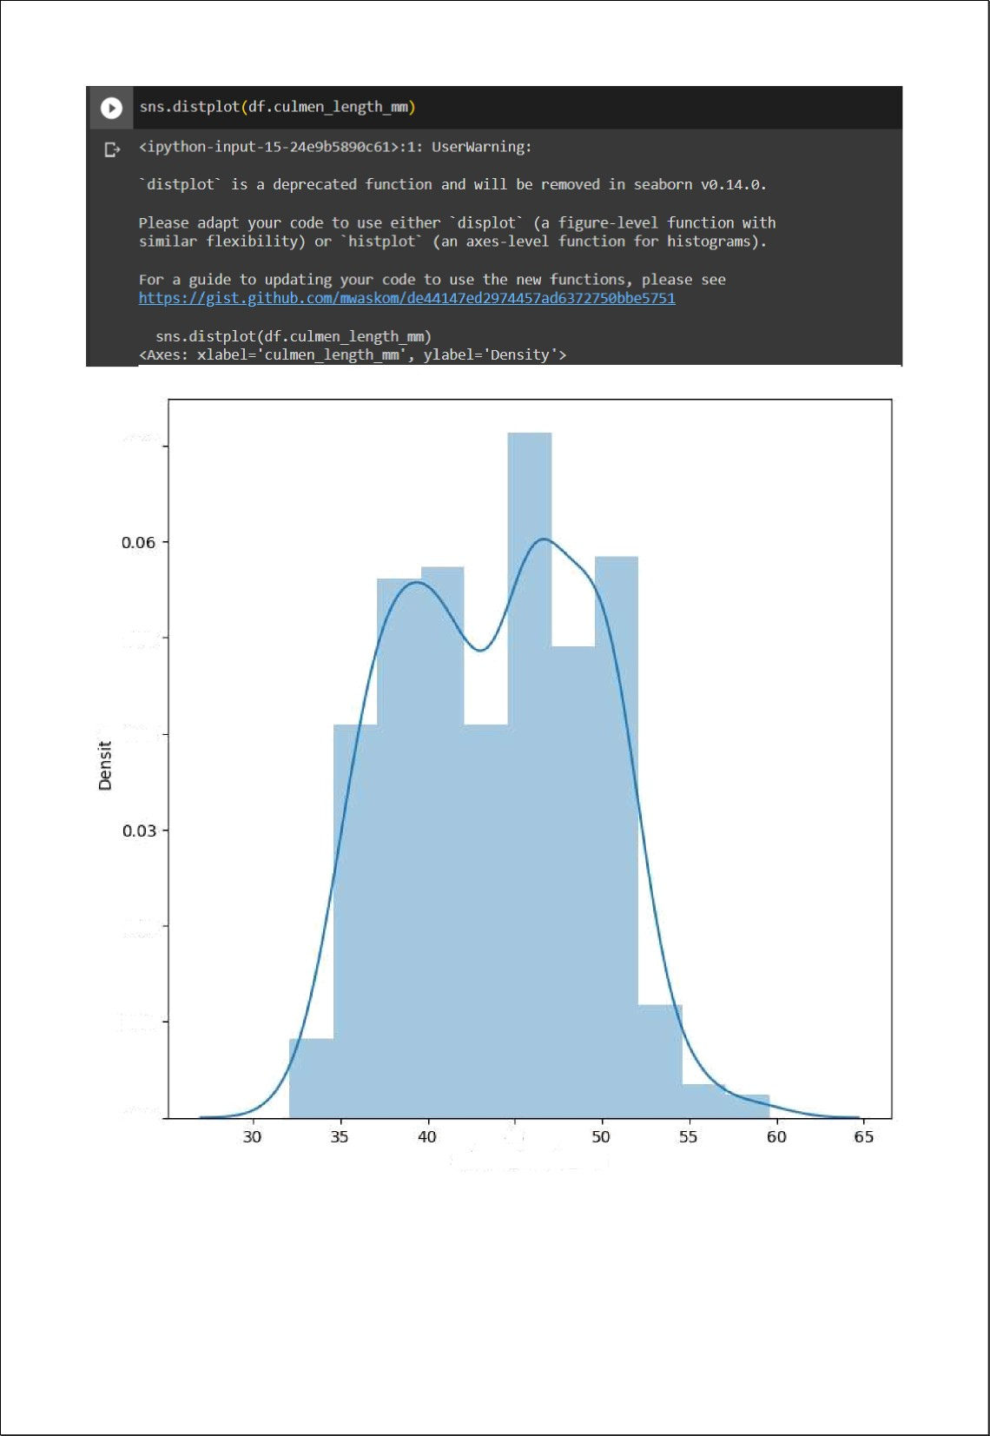

0.D7

0.05

+0.04

0.02

D.01

0.DO

culmen length mm

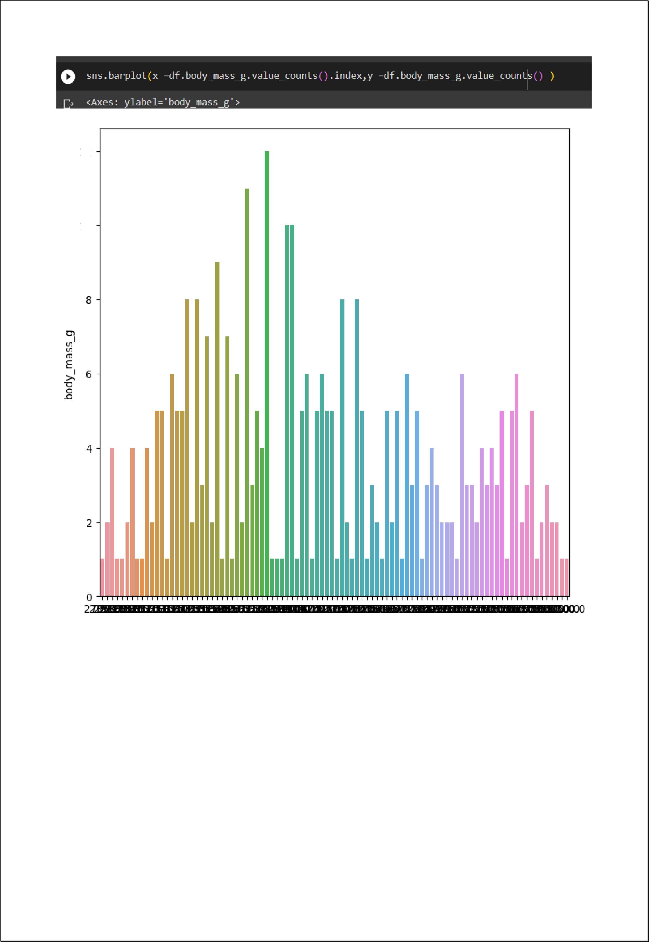

LD

* Bi- Variate Analysis

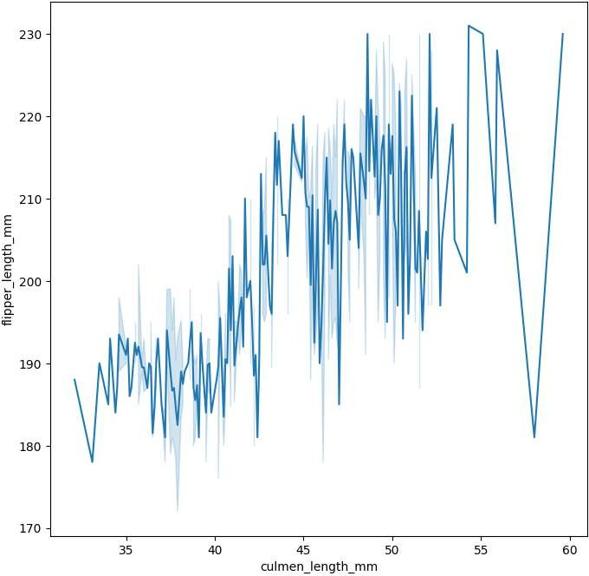

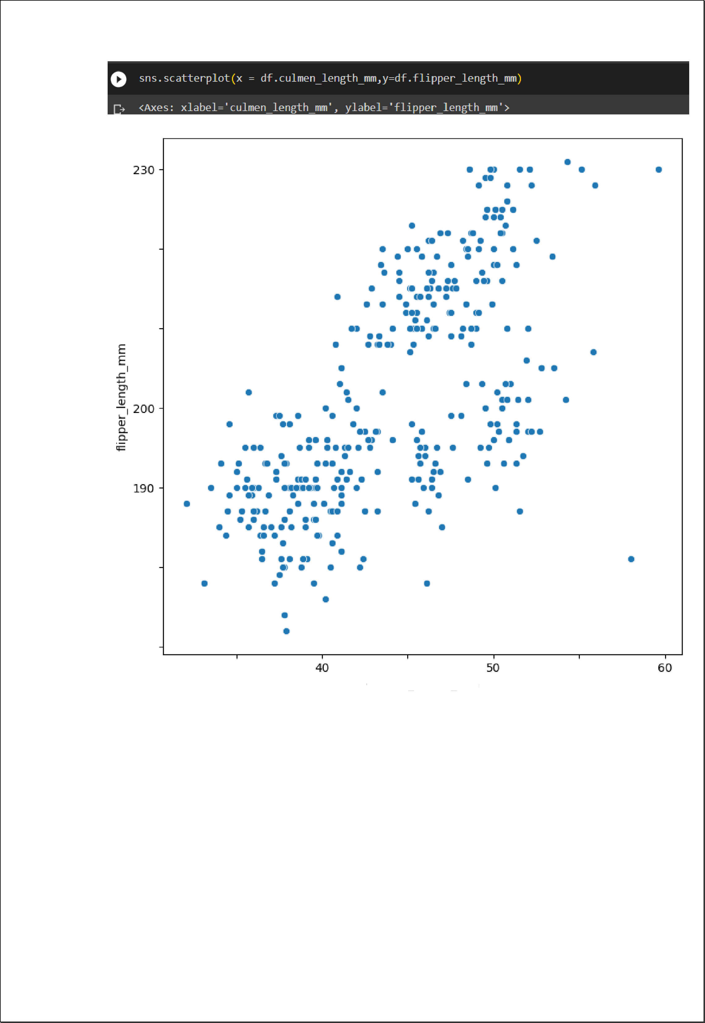

220

210

180

170

35 45 55

culmen length mm

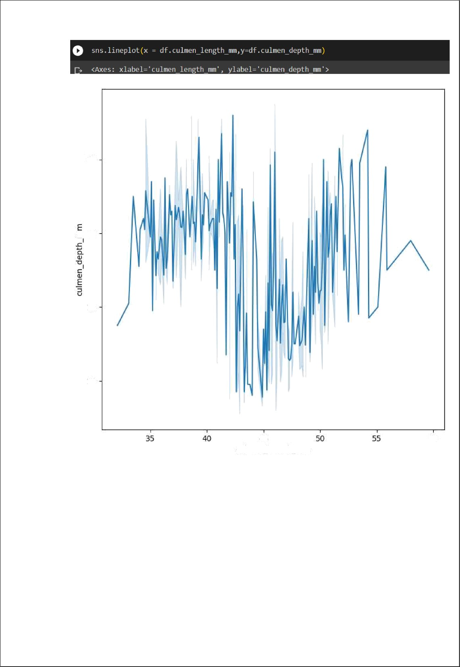

20

ç 18

16

14

45 60

cuÌmen length mm

* Multi-Variate Analysis

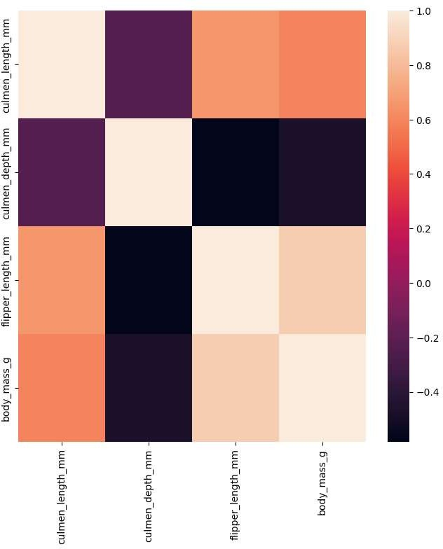



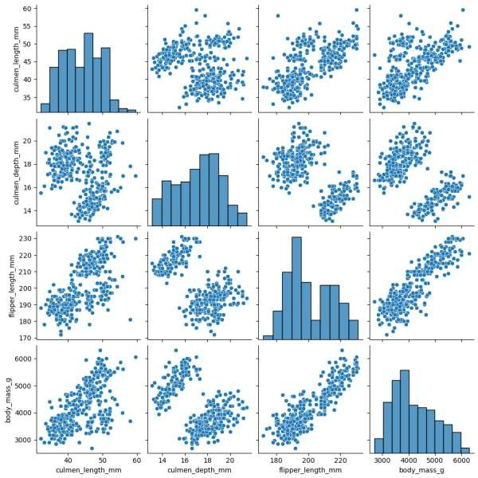

1. Perform descriptive statistics on the dataset

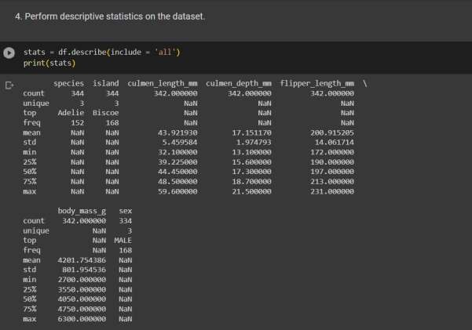

1. Check for Missing values and deal with them.

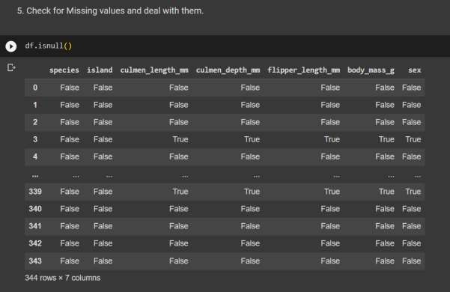

1. Find the outliers and replace them outliers.

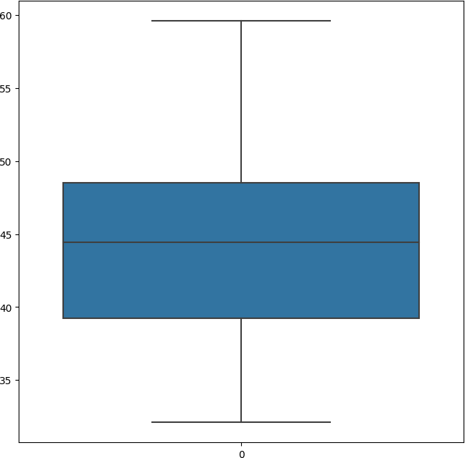

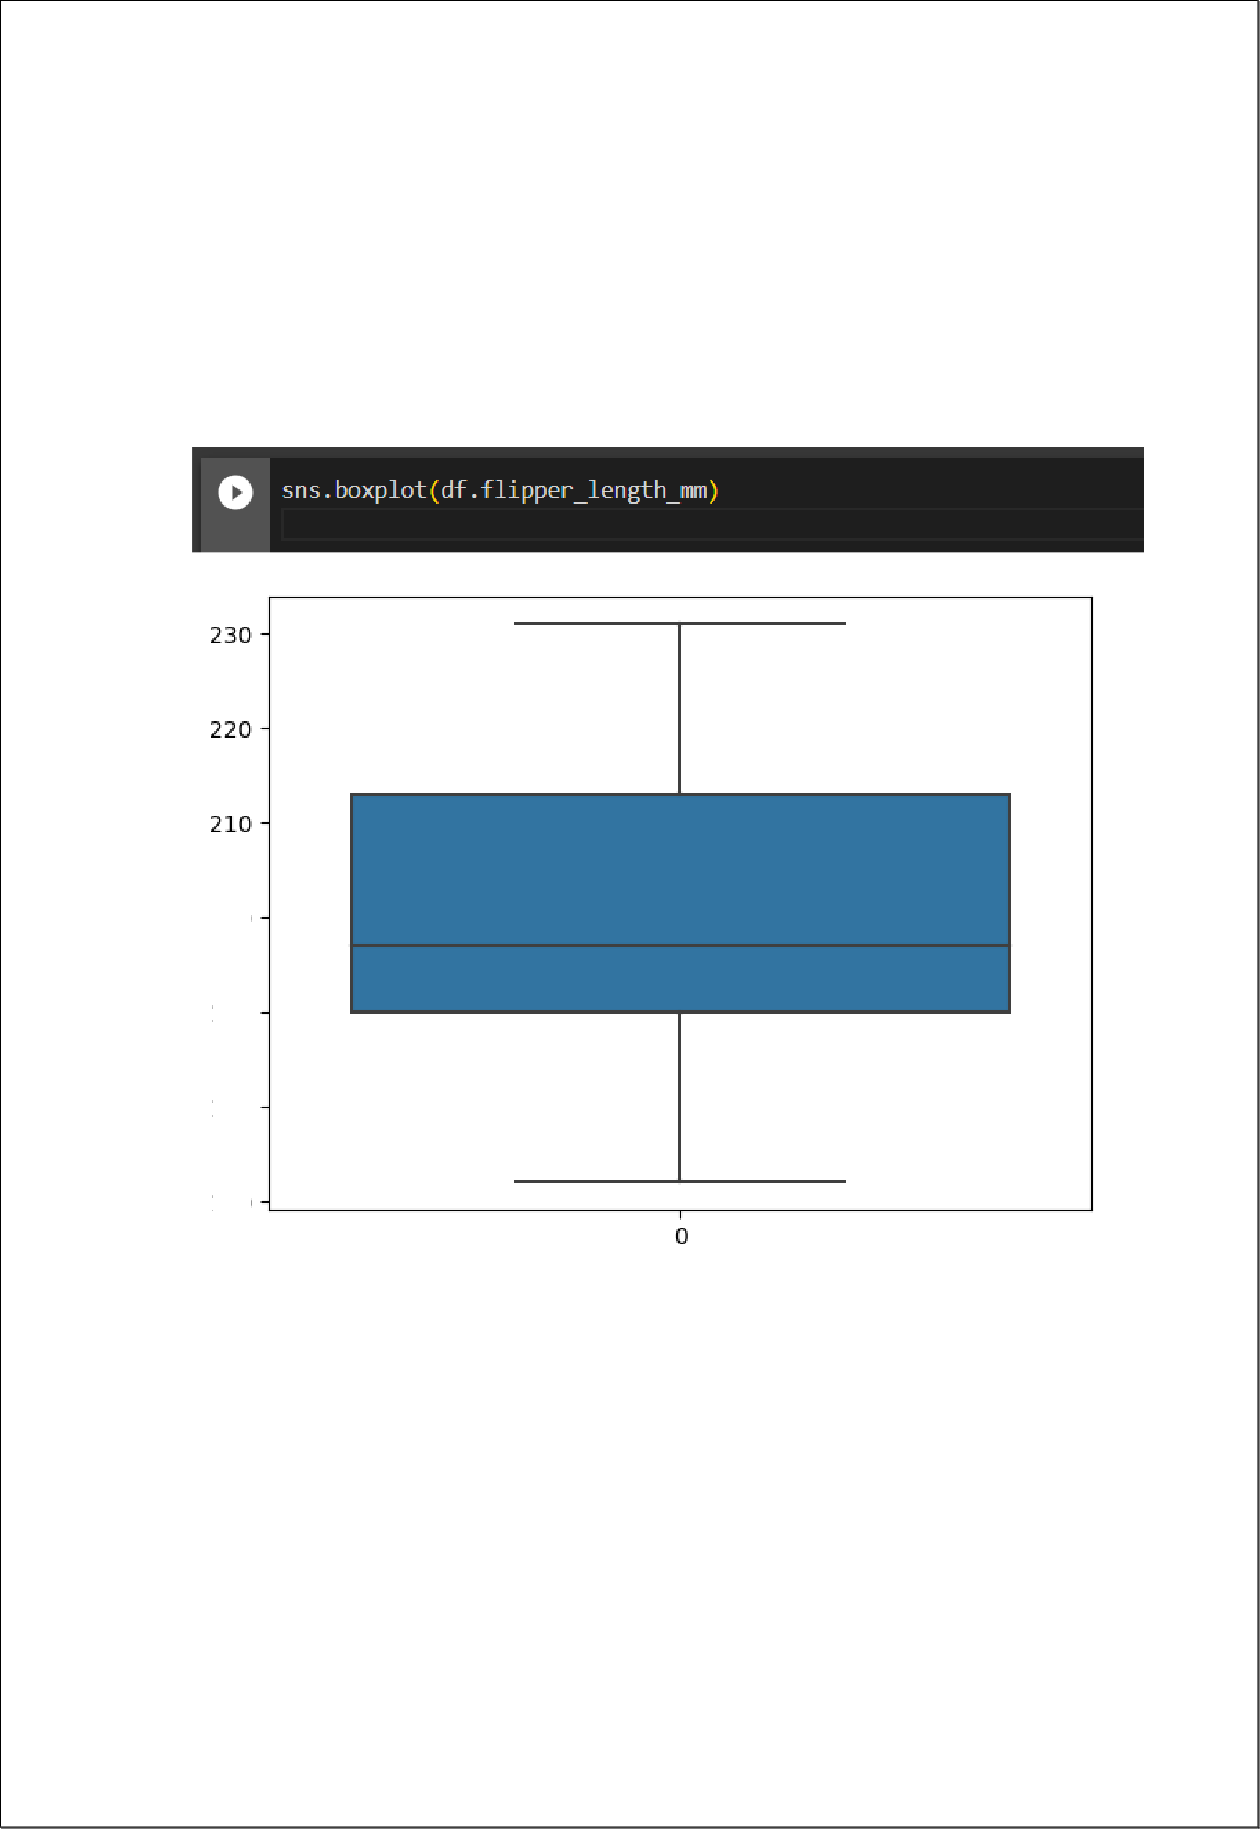

2DO

19D

l7O

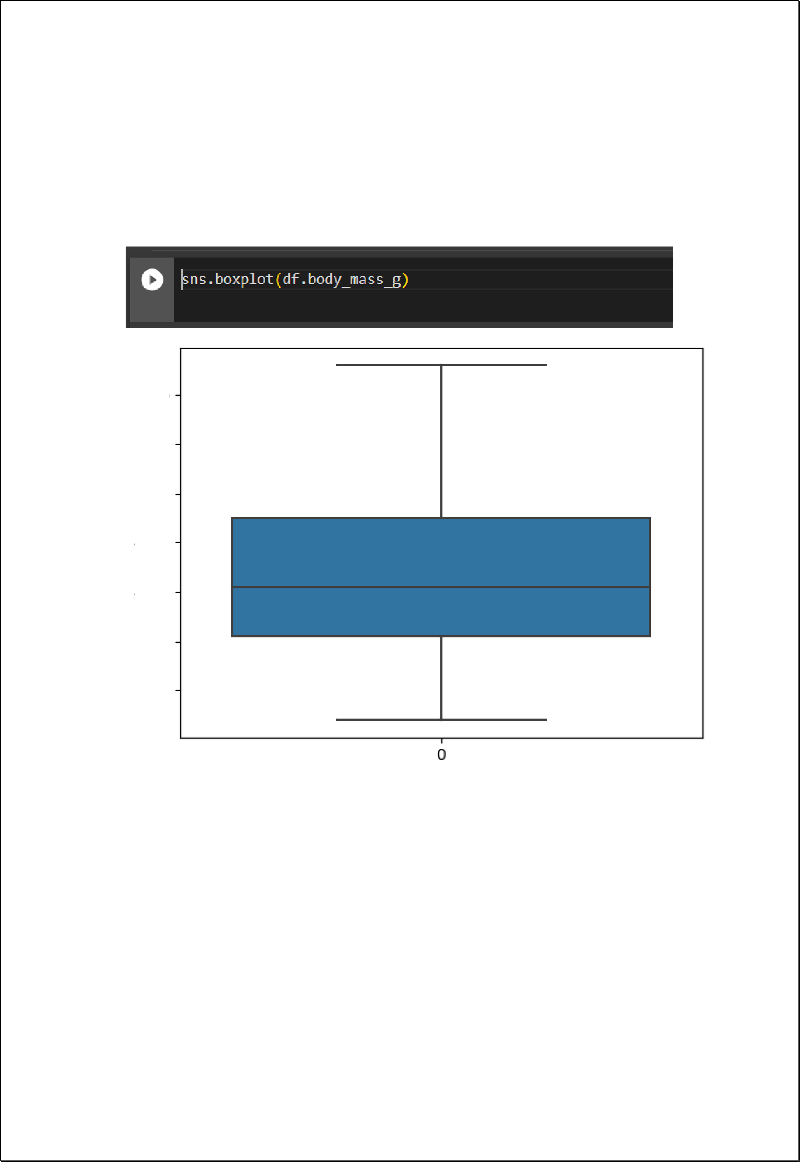

6D00

5õ00

5D00

4500

4D00

3õ00

3D00

1. Check the correlation of independent variables with the target.

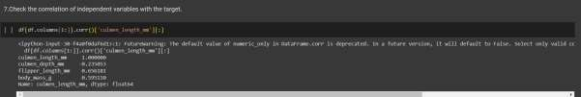

1. Check for Categorical columns and perform encoding.

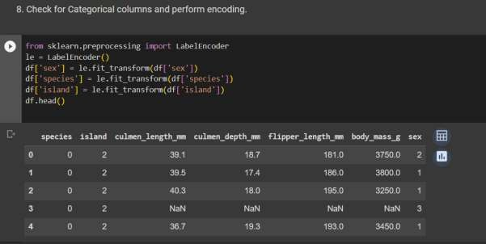

1. Split the data into dependent and independent variables.

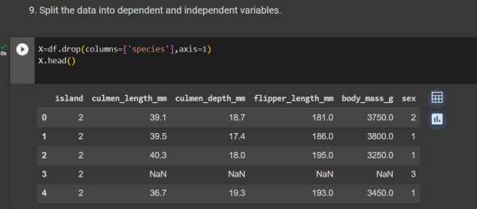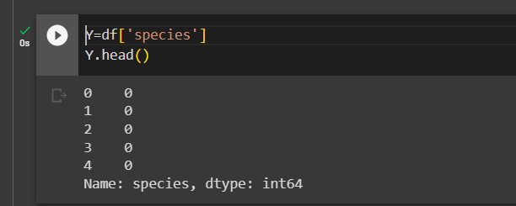

1. Scaling the data

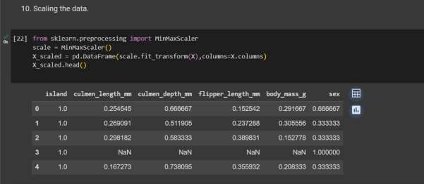

1. Split the data into training and testing.

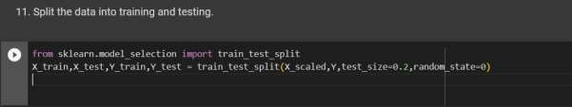

1. check the training and testing data shape.

